**DAILY ONLINE ACTIVITIES SUMMARY**

|  |  |  |  |  |  |  |  |  |
| --- | --- | --- | --- | --- | --- | --- | --- | --- |
| **Date:** | 19-05-2020 | | | | | **Name:** | K S Prajwal | |
| **Sem & Sec** | IV A sec | | | | | **USN:** | 4AL18CS032 | |
| **Online Test Summary** | | | | | | | | |
| **Subject** | | DAA | | | | | | |
| **Max. Marks** | | 30 | | **Score** | | | 21 | |
| **Certification Course Summary** | | | | | | | | |
| **Course** | Python for Machine learning | | | | | | | |
| **Certificate Provider** | | | Greatlearning.in | | **Duration** | | | **2 hr** |
| **Coding Challenges** | | | | | | | | |
| **Problem Statement:** 1. To check whether one string is a sub sequence of another string  2. To find the short palindrome of a string  3. To check if a inked list is a palindrome or not using stacks | | | | | | | | |
| **Status:** completed | | | | | | | | |
| **Uploaded the report in Github** | | | | | yes | | | |
| **If yes Repository name** | | | | | Lockdown_coding | | | |
| **Uploaded the report in slack** | | | | | yes | | | |

Online Test Details: (Attach the snapshot and briefly write the report for the same)

Certification Course Details: (Attach the snapshot and briefly write the report for the same)

Coding Challenges Details: (Attach the snapshot and briefly write the report for the same)

**Online Test Details**: The online test was from module 1 which was about Introduction to the subject and asymptotic notations. There were 25 questions and the duration were 30 minutes. The questions were optimal and were easy. The score that I received was 21/30.

**Snapshot**: not taken

Snapshot of certification course:

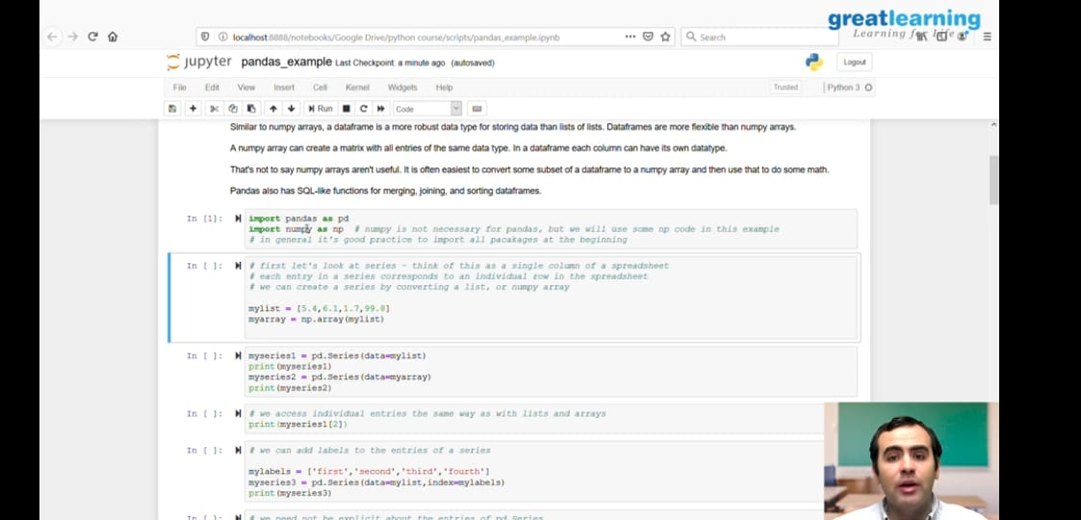

* NumPy Intro-2
* Saving & Loading NumPy Arrays-2
* Numpy and its functions.ipynb
* Pandas - Introduction-2
* Pandas - Series and Dataframes-2
* Pandas - Accessing and modifying-2
* Pandas - Combining Dataframes-2
* Pandas - Functions-2
* Pandas - Saving and Loading dataframes-2

**Online coding:**

Problem 1: (using C language) A user will input two strings, and we find if one of the strings is a sub sequence of the other. Program prints “yes” if either the first string is a sub sequence of the second string or the second string is a sub sequence of the first string. Assume that, the length of the first string is smaller than or equal to the length of the second string.

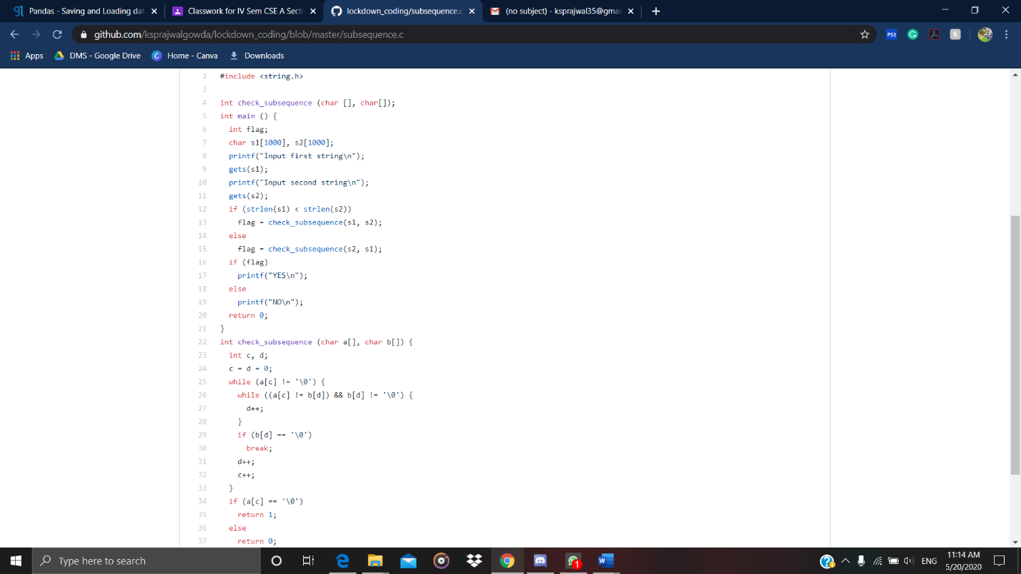

Problem 2: (Using JAVA) We have a Letter or a word then we need add some letters to it and need to find out shortest palindrome. For example we take “S”, “S” will be the shortest palindrome string. If we take “xyz”, “zyxyz” will be the shortest palindrome string. So we need to add some characters to the given string or character and find out what will be the shortest palindrome string.

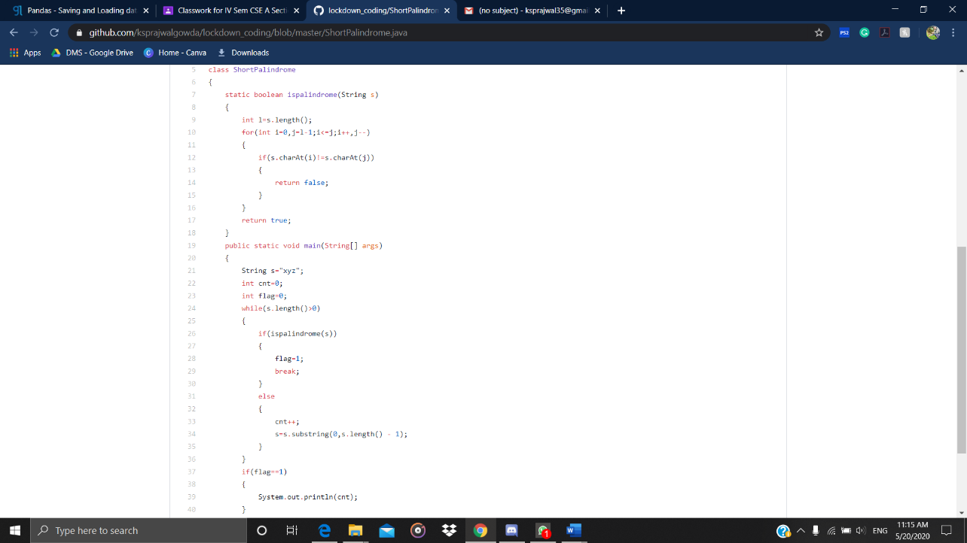

Problem 3: Write a simple code to identify given linked list is palindrome or not by using stack.  
First take a Stack. Traverse through each node of the linked list and push each node value to stack. Once the traversal & copying is done, iterate through linked list from head node again.  
In each iteration, pop one stack element and compare with node value in respective iteration. It is expected to match stack popped value with node value. In case of all matches, it’s a palindrome. Any one element mismatch makes it not a palindrome.

